Analyze Result
Analysis notes — Section 3: Data Structure and Participant Public Transport Use Frequency
**Source file and date:**
The analysis used the de-identified file `quantity_data.csv`, prepared and uploaded on 13 September 2026.

**Participants and interview coverage:**
The dataset contains 16 participants, and all 16 participants completed the qualitative interview component. Because there is no non-interviewed subgroup, an interviewee-versus-non-interviewee comparison is not applicable in this study.

**Missing values:**
No missing values were detected in the uploaded dataset.

**Changes made to the CSV before analysis:**
Before upload, the CSV was cleaned so that column names used underscores rather than spaces. Completion time was converted to seconds and stored as numeric values. A standardised `Task_Outcome` column was added using the categories `unaided`, `assisted`, and `not_completed`. `Public_Transport_Use_Frequency` was also added as a participant-level background variable.

**What I see:**
9 of 16 participants reported a high level of public transport use frequency, while 7 of 16 reported a moderate level. No participants in this sample were classified as low-frequency public transport users. The sample therefore mainly represents participants who already use public transport relatively regularly.

**Which committed question this bears on:**
This result does not directly answer one of the committed evaluation questions. Instead, it provides important participant-context information for interpreting later findings about usability, disruption-information understanding, decision confidence, and perceived usefulness.

**Register — demonstrates / suggests / cannot establish — and why:**
This **demonstrates** the composition of this participant sample because public transport use frequency was directly recorded for all 16 participants. However, it cannot establish the transport-use patterns of international students more generally, and it should not be used to generalise beyond this sample.

**What the interviews need to explain, or what I want to check next:**
The qualitative data should be checked for whether participants with different levels of public transport use describe different expectations, difficulties, or information needs when responding to service disruptions. In particular, it may be useful to examine whether higher-frequency users rely more on prior knowledge, familiar routes, or existing transport apps when interpreting disruption information and comparing alternative options.

**Deviations from the plan that affect this:**
No major procedural deviation directly affects this descriptive result. However, the sample contains only moderate- and high-frequency public transport users, with no low-frequency users represented. This is an important sampling limitation. If participants generally perform well with the prototype, part of that performance may reflect their existing familiarity with public transport rather than the prototype alone. This may limit how confidently later findings can be interpreted for international students who are less familiar with the transport system.

Analysis notes — Section 4: Overall Task Outcome
Fifteen of sixteen participants (94%) completed the task unaided, while one participant (6%) completed it with assistance. No participant was classified as `not_completed`, and all participants reached a viable final travel action. This bears directly on the Layer 1.1 evaluation question of whether participants can understand the disruption situation and use the prototype to make an appropriate next travel decision without assistance.
The register is **suggests**: the large majority of participants were able to complete the task independently, which suggests that the prototype generally supported independent decision-making in this sample. However, the result does not establish that all international students would be able to do the same, particularly because the sample contained only moderate- and high-frequency public transport users.
The assisted completion should be examined in the qualitative and observational data to identify where support was required and whether the difficulty came from interpreting the disruption, understanding its impact, comparing alternatives, or selecting the final action. The qualitative data should also be checked for participants who were classified as unaided but still showed hesitation or uncertainty, because successful task completion does not necessarily mean that the process was effortless or fully clear.
The classification used here should also be kept in mind when interpreting the result: assistance levels 0–1 were treated as `unaided`, while level 2 or above was treated as `assisted`. This means the outcome reflects independent completion under the study's predefined assistance criteria rather than the complete absence of any moderator interaction.

Analysis notes — Section 5: Completion Time
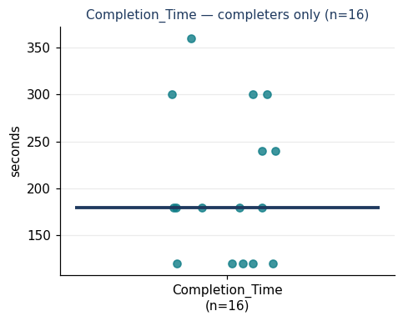
All 16 participants completed the task. The median completion time was 180 seconds, with a range from 120 to 360 seconds. The mean completion time was 202.5 seconds (SD = 78.6 seconds). Most participants completed the task between 120 and 300 seconds, while one participant took 360 seconds.
This bears on the Layer 1.1 usability question by describing how efficiently participants were able to work through the prototype and reach a final travel decision.

This **demonstrates** the completion-time distribution for these 16 participants. It **suggests** that most participants were able to complete the task within a relatively short period, but the spread in completion times indicates that some participants required substantially more time than others. It cannot establish that the prototype would produce the same completion times for international students more generally.
The qualitative data should be checked to understand why some participants took longer than others, especially the participant who required 360 seconds. Relevant explanations may include hesitation, difficulty interpreting disruption information, comparing alternatives, uncertainty about the final decision, or differences in prior public transport experience.
No major procedural deviation directly affects the completion-time measure. However, because the sample includes only moderate- and high-frequency public transport users, completion times may partly reflect participants' prior familiarity with public transport rather than the prototype alone.

Analysis notes — Sections 6-7: Questionnaire and Likert Evidence
**Information clarity and decision support**
Fourteen of sixteen participants rated the ease of comparing travel options as 4 or 5, and thirteen of sixteen rated next-step clarity as 4 or 5; both measures had a median of 4. This bears on the evaluation question of whether the prototype helps participants understand the disruption situation and decide what to do next. The register is **suggests**: most participants rated the decision-support process positively, but the ratings alone cannot show which specific information or interface element made the process clear. The interview data should therefore be used to identify which parts of the information supported comparison and action selection, and where participants still experienced hesitation or confusion.

**Perceived usefulness**
The strongest usefulness result concerned deciding whether the current travel plan needed to change: 9 of 16 participants selected the highest rating of 5, with a median of 5. Understanding how the disruption affected the participant's own journey was also rated strongly, with 8 of 16 selecting 5 and a median of 4.5. The broader usefulness measures remained positive, with medians of 4. This bears on the question of whether the prototype provides meaningful decision support during disruption. The register is **suggests**: the prototype appears to be particularly useful for helping participants judge whether action is necessary, rather than simply presenting disruption information. The interviews should explain what information participants relied on when deciding whether to continue their current journey or change plans.

**Decision confidence**
Thirteen of sixteen participants rated their overall decision confidence as 4 or 5, with a median of 4. However, the ratings specifically concerning whether the prototype information increased confidence were more dispersed, despite also having a median of 4. This bears on the question of whether the prototype reduces uncertainty and supports confidence in travel decisions. The register is **suggests**: participants were generally confident in their final decisions, but the quantitative results do not establish that this confidence came entirely from the prototype. The interviews should therefore examine whether confidence came from the presented information, prior public transport experience, route familiarity, or knowledge from other transport tools.

**Perceived ease of use**
All four ease-of-use measures had a median of 4, and most responses were concentrated at 4 or 5. This bears on the evaluation question of whether participants found the prototype understandable and easy to use. The register is **suggests**: participants generally perceived the prototype as learnable, understandable, and manageable to navigate, but this sample contained only moderate- and high-frequency public transport users. Some of the perceived ease may therefore reflect prior familiarity with public transport rather than the interface alone. The qualitative data should be checked for any usability difficulties that were not visible in the positive ratings.

SUS and NASA-TLX were not used in this study, so Section 6 did not produce a standardised usability or workload score. The evidence in this section instead comes from the project-specific quick-evaluation items and the adapted TAM measures, and should be interpreted descriptively for this participant sample.

Decided in advance — Section 8 (association)
**Formal Section 8 associations:**
No formal association was run because the available participant-level background variable, public transport use frequency, is categorical (`Moderate` / `High`) and is more appropriate for the two-group comparison in Section 9.

**Exploratory association:**
Perceived usefulness against decision confidence — explored to see whether participants who perceived the prototype as more useful also tended to report higher decision confidence. This was not pre-specified as a formal Section 8 association because both variables are outcome measures rather than participant characteristics.
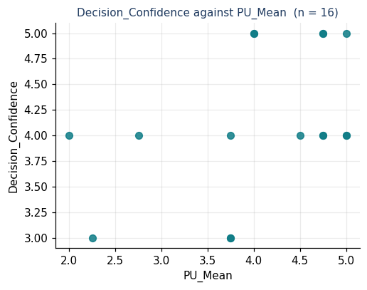
Analysis notes — Section 8 (association)
**Exploratory association — perceived usefulness and decision confidence**
The scatterplot shows a moderate positive pattern between perceived usefulness and decision confidence. Spearman's ρ was 0.46 (n = 16, p = .071). This does not reach the conventional p < .05 threshold, but it suggests that participants who perceived the prototype as more useful also tended to report higher decision confidence.
Because this analysis was exploratory rather than pre-specified, it should not be treated as a confirmatory finding. The association also does not establish causation. The interview data should be used to examine whether higher confidence was related to the prototype's usefulness, prior public transport experience, route familiarity, or other sources of information.

> ### 📝 Decided in advance — Section 9 (difference)
>**Comparison 1:** Completion time between participants with High and Moderate public transport use frequency — because the evaluation asks whether participants can efficiently interpret disruption information and reach a travel decision, and prior transport familiarity may affect how quickly they complete the task.

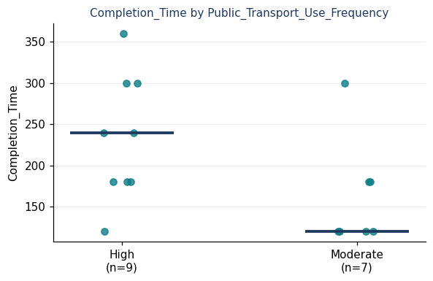
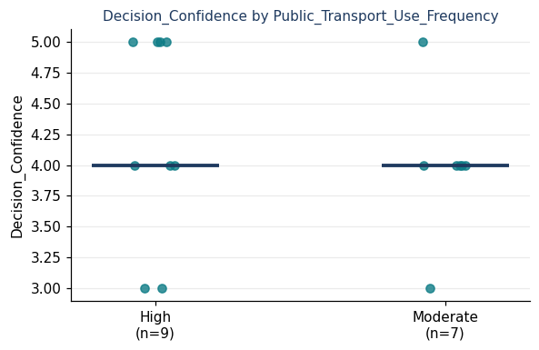
>**Comparison 2:** Decision confidence between participants with High and Moderate public transport use frequency — because the evaluation asks whether the prototype supports confident decision-making, and prior public transport familiarity may influence participants' confidence when responding to disruption information.
Analysis notes — Section 9: Differences by Public Transport Use Frequency
**Completion time by public transport use frequency**
Participants with high public transport use frequency (n = 9) had a median completion time of 240 seconds, while participants with moderate use frequency (n = 7) had a median of 120 seconds. The dot plot shows considerable spread within both groups, particularly among the high-frequency users, whose completion times ranged from relatively short to the longest time observed in the dataset. The Mann–Whitney test gave U = 49.0, p = .063.
This bears on the question of whether prior public transport familiarity may influence how efficiently participants interpret disruption information and reach a travel decision. The register is **suggests**: in this sample, high-frequency users actually tended to take longer rather than complete the task faster. However, the test could not distinguish this observed difference from chance at the conventional p < .05 level, and the two groups are small. It therefore cannot establish that public transport use frequency is associated with completion speed.
The qualitative and observational data should be checked to explain why some high-frequency users took longer. One possibility to examine is whether more experienced users considered more alternatives, compared the prototype against their existing knowledge, or questioned the information more carefully rather than simply completing the task faster. The interviews should also help determine whether the longer times reflected difficulty or more deliberate decision-making.
**Decision confidence by public transport use frequency**
Both groups had a median decision-confidence rating of 4. High-frequency users (n = 9) and moderate-frequency users (n = 7) showed substantial overlap in their ratings, with scores in both groups ranging from 3 to 5. The Mann–Whitney test gave U = 37.5, p = .526.
This bears on the question of whether participants' prior public transport familiarity may contribute to their confidence when making disruption-related travel decisions. The register is **cannot establish**: the current sample provides no clear quantitative evidence that decision confidence differed according to public transport use frequency. This should not be interpreted as evidence that the groups are identical; with only 9 and 7 participants, the study is too small to detect anything other than a relatively large difference.
The interview data should therefore be used to examine where participants said their confidence came from — for example, the prototype information, familiarity with the route, prior public transport experience, or other transport tools. This is particularly important because the earlier questionnaire results suggested that final decision confidence was generally positive even though the extent to which the prototype information itself increased confidence was more variable.

Analysis notes — Section 10: Interviewee Typicality

This comparison is not applicable in this study because all 16 participants completed the qualitative interview component. There is therefore no non-interviewed subgroup against which the interview participants can be compared.
Because the qualitative and quantitative data were collected from the same participant sample, the qualitative findings are not based on a smaller selected subgroup. However, the limitations of the overall participant sample still apply, including the absence of low-frequency public transport users.

Summary notes — what the numbers say so far
**Committed question 1:**
The quantitative results suggest that the prototype generally supported independent task completion in this sample. Fifteen of sixteen participants (94%) completed the task unaided, all participants reached a viable final action, and the median completion time was 180 seconds, although times ranged from 120 to 360 seconds.

**Committed question 2:**
The ratings suggest that participants generally found the prototype clear and usable for comparing options and identifying what to do next. Option comparison and next-step clarity both had a median of 4, while all four ease-of-use measures also had a median of 4, although the quantitative data alone cannot explain where any remaining confusion or hesitation occurred.

**Committed question 3:**
The results suggest that the prototype provided useful decision support and was associated with generally positive decision confidence. The strongest usefulness evidence concerned helping participants decide whether their travel plan needed to change, with a median of 5, while overall decision confidence had a median of 4; an exploratory association between perceived usefulness and decision confidence showed a moderate positive pattern (Spearman's ρ = 0.46, n = 16, p = .071), but this did not reach the conventional p < .05 threshold.

**Limitations the numbers already show:**
The sample included only 16 participants and contained only moderate- and high-frequency public transport users, with no low-frequency users represented. All 16 participants completed the interview component, so there was no separate interview subgroup to assess for typicality. In addition, participant characteristics such as age, prior experience with public transport applications, and general device or digital-interface experience were not included in the quantitative dataset. These factors may have influenced completion time, perceived ease of use, perceived usefulness, and decision confidence, but their effects cannot be examined with the current quantitative data.
Public transport use frequency showed an observed difference in completion time (median 240 seconds for High vs 120 seconds for Moderate), but the sample was too small to distinguish this difference from chance (U = 49.0, p = .063). The quantitative findings should therefore be treated as descriptive evidence from this sample and interpreted together with the qualitative and observational data.

Coding and Classification Criteria for Quantitative Data
The following criteria were used consistently when converting observation records, participant responses, and test outcomes into categorical variables for quantitative analysis. These definitions were established to ensure that the same interpretation was applied across all participants.

1. Task Checkpoint Variables
The following variables represent participants’ performance at different stages of the task:
- Task_Start_Completed
- Task_Understand_Disruption
- Task_Identify_Impact
- Task_Judge_Action
- Task_Compare_Options
- Task_Select_Action

Each checkpoint was coded using the following criteria:
Yes
The participant demonstrated the expected understanding or completed the required action correctly without substantive researcher assistance.
Partial
The participant demonstrated some correct understanding or progress, but their response was incomplete, uncertain, or required clarification before reaching the expected result.
No
The participant did not demonstrate the required understanding or action, made an incorrect judgement that was not independently corrected, or was unable to complete the checkpoint.
Hesitation alone was not classified as Partial or No if the participant ultimately completed the checkpoint correctly without substantive assistance.

2. Maximum Assistance Level
The maximum level of assistance provided during the task was recorded using a four-level scale.
Level 0 — No assistance
The participant completed the task without researcher intervention.
Level 1 — Neutral prompt
The researcher provided a neutral prompt that did not indicate the correct answer, required action, or location of information.
Level 2 — Procedural hint
The researcher provided guidance that helped the participant identify how or where to proceed.
Level 3 — Direct instruction
The researcher explicitly told the participant what action to take or provided the information required to continue.
For quantitative analysis, Levels 0–1 were treated as independent completion, while Levels 2–3 were treated as assisted completion.

3. Overall Task Outcome
Overall task outcome was classified according to whether the participant reached a viable final travel decision and the maximum level of assistance required.
Unaided
The participant reached a viable final travel action with a maximum assistance level of 0 or 1.
Assisted
The participant reached a viable final travel action but required assistance at Level 2 or 3.
Not completed
The participant did not reach a viable final action, abandoned the task, or required the researcher to provide the final decision or answer.
This variable represents the overall independence of task completion rather than whether every intermediate checkpoint was completed perfectly.

4. Final Action Viability
Final action viability indicates whether the participant ultimately selected a workable travel response to the disruption scenario.
Viable
The participant selected a travel action that could reasonably be carried out and appropriately responded to the disruption presented in the scenario.
Not viable
The selected action did not adequately respond to the disruption or would not allow the participant to continue the journey as required.
A viable final action does not necessarily mean that the participant completed the process without difficulty or assistance.

5. Useful Disruption Contexts
The following variables record the situations in which participants indicated that they would want disruption information or decision support:
- Useful_Early_Service
- Useful_Delayed_Service
- Useful_Cancelled_Changed
- Useful_On_Time
- Useful_Other
Each variable was coded as:
Yes
The participant selected that situation as one in which they would want this type of information or decision support.
No
The participant did not select that situation.
These variables represent participant preferences and should not be interpreted as task-performance measures.

6. Public Transport Use Frequency
Public_Transport_Use_Frequency was based directly on participants’ self-reported public transport use frequency during data collection.
High
The participant self-reported their public transport use frequency as High.
Moderate
The participant self-reported their public transport use frequency as Moderate.
These categories were retained exactly as reported by participants and were used as categorical participant-background variables. No additional threshold, numerical conversion, or post-hoc reclassification was introduced during quantitative analysis.

7. Completion Time
Completion_Time represents the time required for the participant to complete the task and reach a final travel decision.
All completion times were converted to and recorded in seconds before quantitative analysis to ensure consistent measurement across participants.
Completion time was treated as a numeric measure. It was interpreted alongside task outcome and qualitative observations, as a longer completion time does not necessarily indicate poorer performance; it may also reflect more extensive comparison, hesitation, or deliberation.

8. Likert-Scale Ratings
Quick-evaluation and TAM questionnaire items used a five-point Likert scale:
1 — Strongly disagree
2 — Disagree
3 — Neutral
4 — Agree
5 — Strongly agree
Individual Likert items were treated as ordinal variables and were primarily described using response counts and medians.
The adapted TAM questionnaire contained two constructs:
Perceived Usefulness (PU)
Calculated from PU1–PU4.
Perceived Ease of Use (PEOU)
Calculated from PEOU1–PEOU4.
For each participant, PU_Mean and PEOU_Mean were calculated as the mean of the four corresponding items. The supplementary decision-confidence item was analysed separately and was not included in either TAM construct.

9. General Coding Rules
All categorical values were derived from the original observation sheets, participant responses, and test records rather than inferred retrospectively from later interview interpretation.
Prototype malfunctions or technical failures were not classified as participant errors or failures.
Where available evidence was insufficient to support a classification, the value should be treated as missing rather than inferred.
The same definitions and coding rules were applied consistently across all participants to maintain comparability within the quantitative dataset.

